Synopsis

Loan Default Prediction Using Machine Learning Techniques

Project Id: 2

Student Name: Khushi Kalra
Anshika Goswami
Sanskar Pandey
University Roll number : 2028445
2028392
2028484
Section-P

1. Problem Description.......................................................... 3
2. Architecture ...................................................................... 4
3. Models model..................................................................... 5
4. Evaluation metrics used.................................................... 6
5. Preliminary Results and Visualizations.......................... 7
6. References........................................................................... 8

1. Problem Description
In the banking and financial sector, predicting whether a customer will default on a loan is a critical task. Loan default can lead to significant financial losses for institutions, making it essential to identify high-risk customers before approving loans. Traditional methods rely heavily on manual assessment and basic statistical analysis, which may not capture complex patterns in large-scale customer data.
The objective of this project is to design and develop an end-to-end machine learning classification system that can accurately predict loan default using customer banking data. The system will analyze various features such as income, credit history, loan amount, and repayment behavior to identify patterns associated with default risk.
The project involves multiple stages including exploratory data analysis (EDA) to understand data distribution and relationships, data preprocessing to handle missing and inconsistent values, and feature transformation techniques such as normalization and Principal Component Analysis (PCA) to improve data quality. Machine learning models such as Support Vector Machine (SVM) with different kernels and K-Nearest Neighbors (KNN) will be implemented to perform classification.
Finally, the models will be evaluated using performance metrics such as precision, recall, F1-score, and ROC-AUC to determine their effectiveness. The goal is to build a reliable and efficient system that assists financial institutions in making data-driven decisions and minimizing the risk of loan defaults.

1.1 Dataset Description
The dataset used in this project consists of customer banking and loan-related information, which is used to predict whether a loan applicant is likely to default or not. It contains both numerical and categorical features representing the financial status, personal details, and credit behavior of applicants.
The dataset includes important attributes such as ApplicantIncome, CoapplicantIncome, LoanAmount, Loan_Amount_Term, and Credit_History, along with other demographic features like gender, marital status, and education. The target variable indicates whether the loan is approved or defaulted.
The data may contain missing values and inconsistencies, which require preprocessing steps such as data cleaning, encoding of categorical variables, and normalization. This dataset is suitable for classification tasks and is widely used for building and evaluating machine learning models like SVM and KNN.

2. Architecture

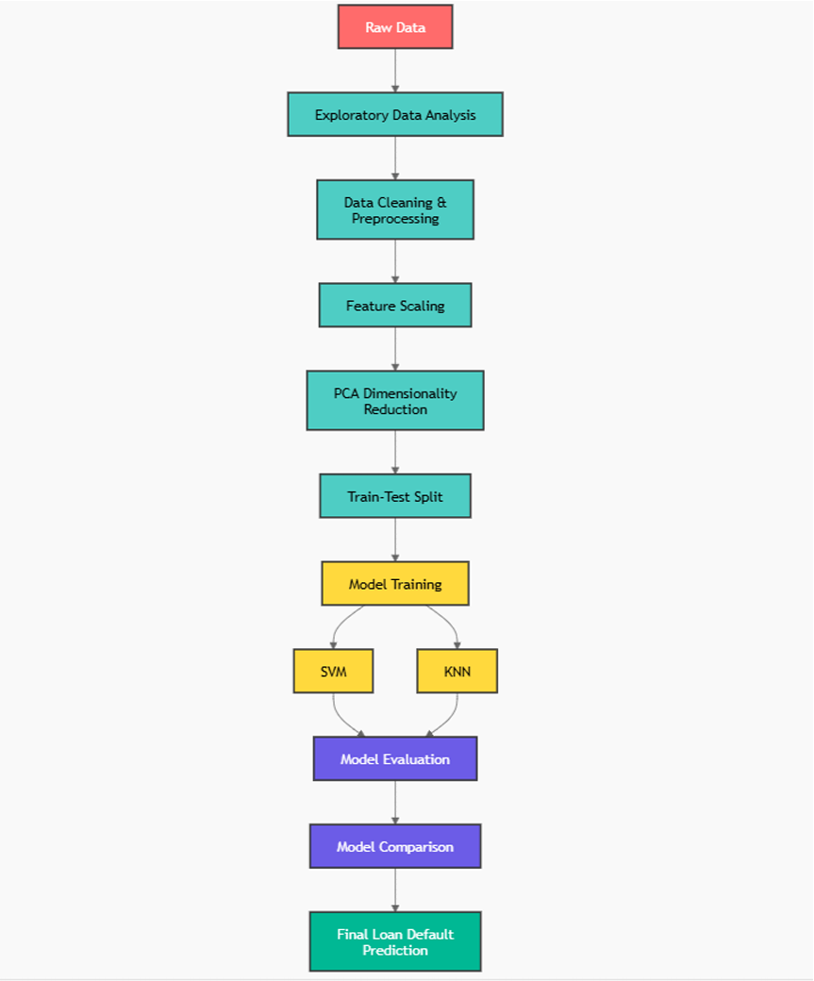

3. Models Used(Applied/ Planned)
Give a brief introduction of the models used

3.1 Modules Used

1. Support Vector Machine (SVM)
Support Vector Machine is a supervised machine learning algorithm used for classification tasks. It works by finding an optimal hyperplane that separates data points of different classes with maximum margin. In this project, different kernel functions such as linear, polynomial, and radial basis function (RBF) are used to handle both linearly and non-linearly separable data.

2. K-Nearest Neighbors (KNN)
K-Nearest Neighbors is a simple and effective classification algorithm that classifies data based on the majority class of its nearest neighbors. It uses distance measures (such as Euclidean distance) to find similarity between data points. In this project, KNN helps in identifying whether a customer is likely to default based on similar past customer behavior.

3. Principal Component Analysis (PCA)
Principal Component Analysis is a dimensionality reduction technique used to reduce the number of features while preserving important information. It transforms the original data into a new set of uncorrelated variables called principal components. In this project, PCA helps in improving model efficiency and reducing computational complexity.

4. Evaluation Metrics Used

1. Precision
Precision measures the proportion of correctly predicted positive cases (loan defaulters) out of all predicted positive cases. It is important when minimizing false positives is critical, such as wrongly classifying a reliable customer as a defaulter.

2. Recall
Recall measures the proportion of actual positive cases (actual defaulters) that were correctly identified by the model. High recall is important in banking to ensure that most risky customers are detected.

3. F1-Score
F1-score is the harmonic mean of precision and recall, providing a balance between both metrics. It is especially useful when the dataset is imbalanced, as it considers both false positives and false negatives.

4. ROC-AUC
ROC-AUC (Receiver Operating Characteristic – Area Under Curve) evaluates the model’s ability to distinguish between defaulters and non-defaulters across different thresholds. A higher AUC value indicates better overall model performance.

5. Preliminary Results and Visualizations
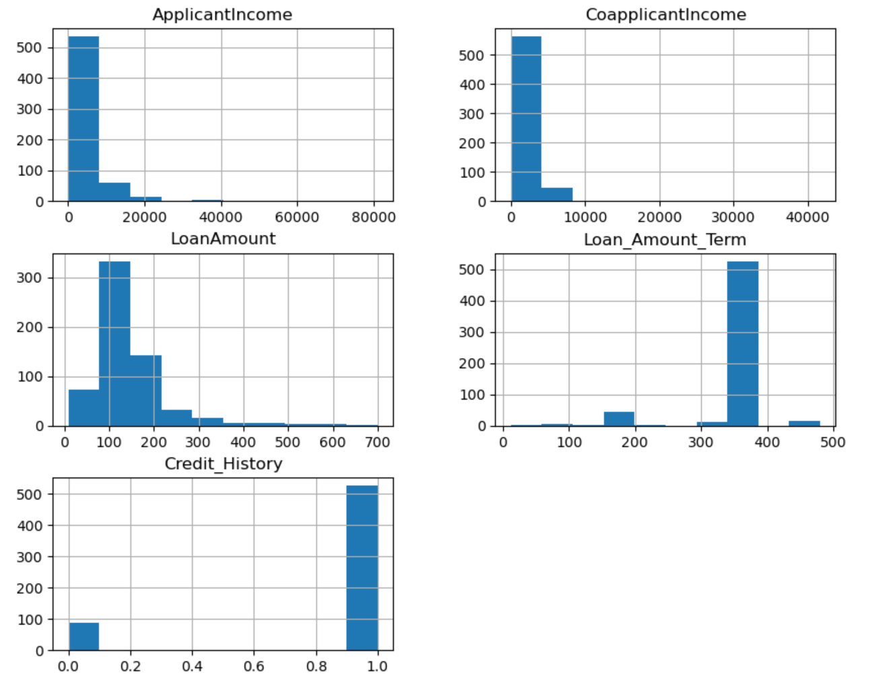
Figure: Histogram plots showing distribution of important loan dataset features.
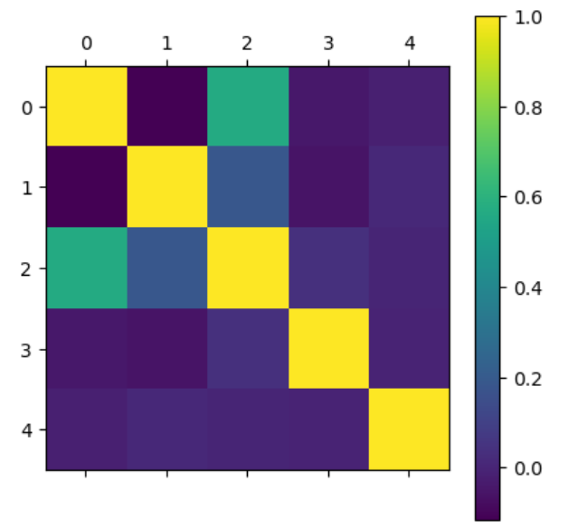
Figure: Correlation heatmap showing the relationship between different features in the dataset.

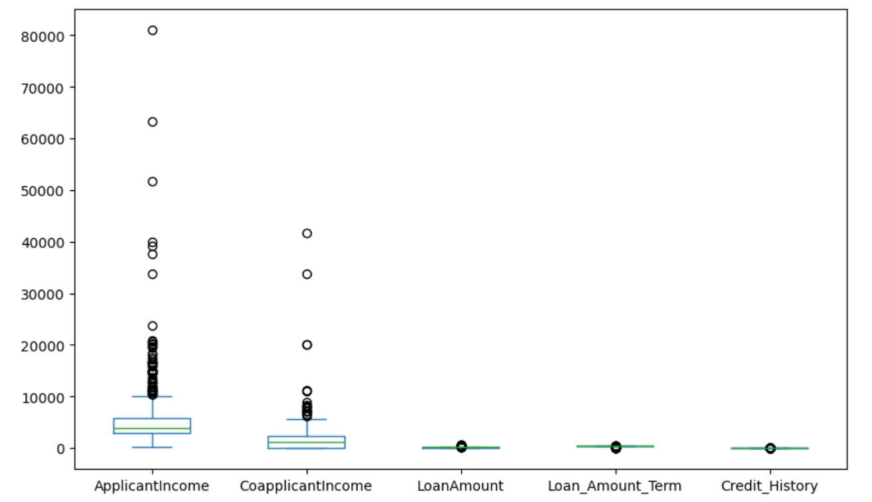
Figure: Box plots of key features showing distribution, median, and presence of outliers in the dataset.
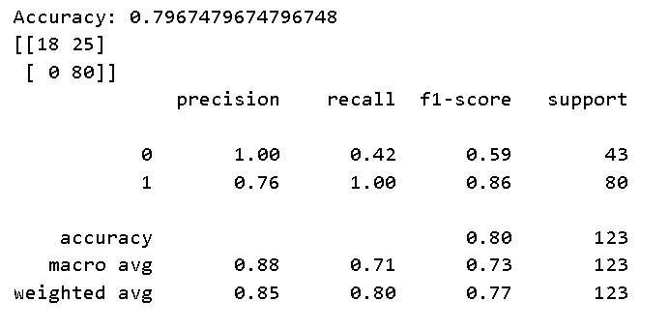
Figure: Classification report and confusion matrix showing performance of the trained model.

6. Conclusion and Future Scope:

Conclusion
This project successfully developed an end-to-end machine learning system for predicting loan default using customer banking data. Through Exploratory Data Analysis (EDA), important patterns and relationships in the dataset were identified, which helped in selecting relevant features and preprocessing techniques. Data cleaning, normalization, and dimensionality reduction using PCA improved the quality of the dataset and enhanced model performance.
Machine learning models such as Support Vector Machine (SVM) with different kernels and K-Nearest Neighbors (KNN) were implemented and evaluated. Among them, SVM demonstrated better performance in handling complex patterns in the data. The evaluation metrics, including precision, recall, F1-score, and ROC-AUC, confirmed that the models are capable of effectively classifying loan defaulters and non-defaulters.
Overall, the project highlights the importance of proper data preprocessing, model selection, and evaluation in building reliable machine learning systems for real-world financial applications.
Future Scope
The project can be further enhanced by incorporating more advanced machine learning and deep learning techniques such as Random Forest, Gradient Boosting, and Neural Networks to improve prediction accuracy. Additionally, hyperparameter tuning and cross-validation can be applied to optimize model performance.
The system can also be extended by using larger and more diverse datasets to improve generalization. Integration with real-time banking systems and deployment as a web application can make the model more practical for real-world use. Furthermore, feature engineering and inclusion of additional financial indicators can help in building a more robust and accurate loan default prediction system.

7. References:
- Hands-On Machine Learning with Scikit-Learn, Keras, and TensorFlow
- Introduction to Machine Learning with Python
- Scikit-learn Official Documentation
https://scikit-learn.org
- Kaggle
https://www.kaggle.com
- Towards Data Science
https://towardsdatascience.com
- GeeksforGeeks
https://www.geeksforgeeks.org

